

**ADDIS ABABA UNIVERSITY**

**ADDIS ABABA INSTITUTE OF TECHNOLOGY**

**CENTER OF INFORMATION TECHNOLOGY AND SCIENTIFIC COMPUTING**

DEPARTMENT OF **SOFTWARE ENGINEERING**

FUNDAMENTALS OF WEB DESIGN AND DEVELOPMENT

**Lecture One Based Assignment**

Eden Tesfaye

ATR/6181/11

Section -2

Submitted to: Mr Fitsum Alemu

February 2020

**1. Internet** was created by Robert Elliot Kahn. Khan was an American electrical engineer, who, along with Vint Cerf, first proposed the Transmission Control Protocol and the Internet Protocol, the fundamental communication protocols at the heart of the Internet.

**Internet** is a worldwide system of interconnected computer networks that use the TCP/IP set of network protocols to reach billions of users.

The Internet is made up of a massive network of specialized computers called routers. Each router's job is to know how to move packets along from their source to their destination. A packet will have moved through multiple routers during its journey. When a packet moves from one router to the next, it's called a hop.

The first workable prototype of the **Internet** came in the late 1960s in California in the United States. In the summer of 1968, the NWG (Network Working Group) held its first meeting, chaired by Elmer Shapiro, at the SRI (Stanford Research Institute) with the creation of ARPANET, or the Advanced Research Projects Agency Network. ... ARPANET adopted TCP/IP on January 1, 1983, and from there researchers began to assemble the “network of networks” that became the modern **Internet.**

The **Advanced Research Projects Agency Network** (**ARPANET**) was the first wide-area packet-switching network with distributed control and the first network to implement the TCP/IP protocol suite. Both technologies became the technical foundation of the Internet. The ARPANET was established by the Advanced Research Projects Agency (ARPA) of the United States Department of Defense. Based on the ideas of J. C. R. Licklider, Bob Taylor initiated the ARPANET project in 1966 and appointed Larry Roberts as program manager. Roberts made the key decisions about the network design. He incorporated Donald Davies’ concepts and designs for packet switching, and sought input from Paul Baran. ARPA awarded the contract to build the network to Bolt Beranek & Newman who developed the first protocol for the network. Roberts engaged Leonard Kleinrock to develop mathematical methods for analyzing the packet network technology. The first computers were connected in 1969 and the Network Control Program was implemented in 1970. Networking research in the early 1970s by Bob Kahn and Vint Cerf led to the formulation of the Transmission Control Program (TCP) in 1974, which incorporated concepts from the French CYCLADES project directed by Louis Pouzin. As the network development progressed, a protocol for internetworking was developed by which multiple separate networks could be joined into a network of networks. Originally referred to as *IP/TCP*, version 4 of TCP/IP was installed in the ARPANET for production use in January 1983 after the Department of Defense made it standard for all military computer networking[[](https://en.wikipedia.org/wiki/ARPANET#cite_note-12) Access to the ARPANET was expanded in 1981, when the National Science Foundation (NSF) funded the Computer Science Network (CSNET). In the early 1980s, the NSF funded the establishment of national supercomputing centers at several universities, and provided network access and network interconnectivity with the NSFNET project in 1986. The ARPANET project was formally decommissioned in 1990, after partnerships with the telecommunication industry paved the way for future commercialization of a new world-wide network, known as the Internet.

History of the Internet: Timeline

1969**:** Arpanet

1969: Unix

1970: Arpanet network

1971: Email

1971: Project Gutenberg and eBooks

1972: CYCLADES

1973: The first trans-Atlantic connection and the popularity of emailing

1974: The beginning of TCP/IP

1975: The email client

1977: The PC modem

1978: The Bulletin Board System (BBS)

1978: Spam is born

1979: MUD – The earliest form of multiplayer games

1979: Usenet

1980: ENQUIRE software

1982: The first emoticon

1984: Domain Name System (DNS)

1985: Virtual communities

1986: Protocol wars

1987: The Internet grows

1988: IRC – Internet Relay Chat

1988: First major malicious internet-based attack

1989: AOL is launched

1989: The proposal for the World Wide Web

1990: First commercial dial-up ISP

1990: World Wide Web protocols finished

1991: MP3 becomes a standard

1991: The first webcam

1993: Mosaic – first graphical web browser for the general public

1993: Governments join in on the fun

1994: Netscape Navigator

1995: Commercialization of the internet

1996: First web-based (webmail) service

1997: The term “weblog” is coined

1998: First new story to be broken online instead of traditional media

1998: Google!

1998: Internet-based file-sharing gets its roots

1999: SETI@home project

2000: The bubble bursts

2001: Wikipedia is launched

2003: VoIP goes mainstream

2003: MySpace becomes the most popular social network

2003: CAN-SPAM Act puts a lid on unsolicited emails

2004: Web 2.0

2004: Social Media and Digg

2004: “The” Facebook open to college students

2005: YouTube – streaming video for the masses

2006: Twitter gets twittering

2007: Major move to place TV shows online

2007: The iPhone and the Mobile Web

2008: “Internet Election”

2009: ICANN policy changes

The **Future** of internet?

In the future internet is authenticated to continue growing.

**3.** **Snapchat, yahoo, amazon, Twitter,Tik-Tok**

* Amazon evolution.

Amazon it started in a garage in 1994 in July 5.And it started on line shopping in 1995. It started to expand every year .I have seen a remarkable change since 2010 in the website of amazon .I personally think the home page of amazon in 2015 is the best .It was clear and an easy style at the same time comfortable. But the 2020 more up-to –date.

### C:\Users\unit-tech\Pictures\IMG_20200305_230753.jpgC:\Users\unit-tech\Pictures\IMG_20200305_230748.jpgC:\Users\unit-tech\Pictures\IMG_20200305_230612.jpgC:\Users\unit-tech\Pictures\IMG_20200305_230609.jpgC:\Users\unit-tech\Pictures\IMG_20200305_230606.jpgC:\Users\unit-tech\Pictures\IMG_20200305_230603.jpgC:\Users\unit-tech\Pictures\IMG_20200305_230600.jpgC:\Users\unit-tech\Pictures\IMG_20200305_230557.jpg

* **Yahoo**

For me yahoo is not the website I choose. And it not popular as others, it design its logo again to remind that it still exist.

There was not much change from 2007-2017 in yahoo. But in 2020 there is a great change in the website of yahoo ,the home page is interesting to see to search.

* **2007**
* 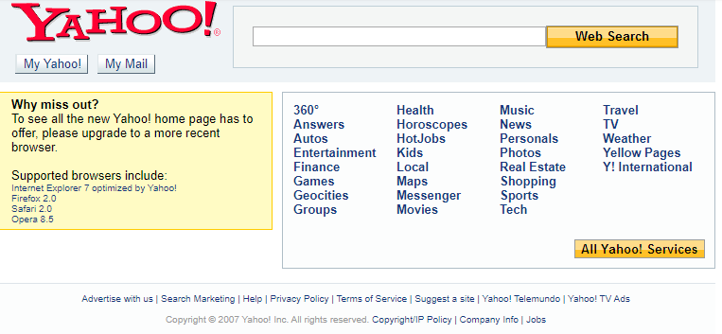
* **2017**

****

* **2020**

**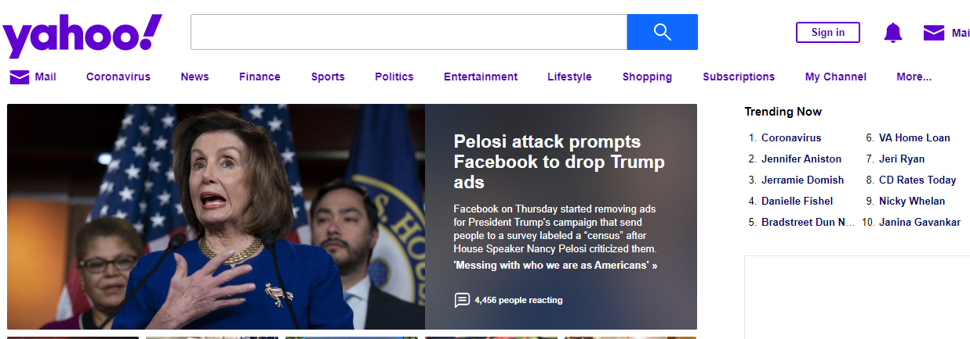**

* **Twitter**

Twitter links transited from HTTP to HTTPS

Twitter spread rapidly across the world.

There is noticeable change in the evaluation of twitter

The way it is now is perfect. I usually choose twitter to see news and I appreciate the clearness and easiness of the website.

**C:\Users\unit-tech\Pictures\IMG_20200306_092426.jpg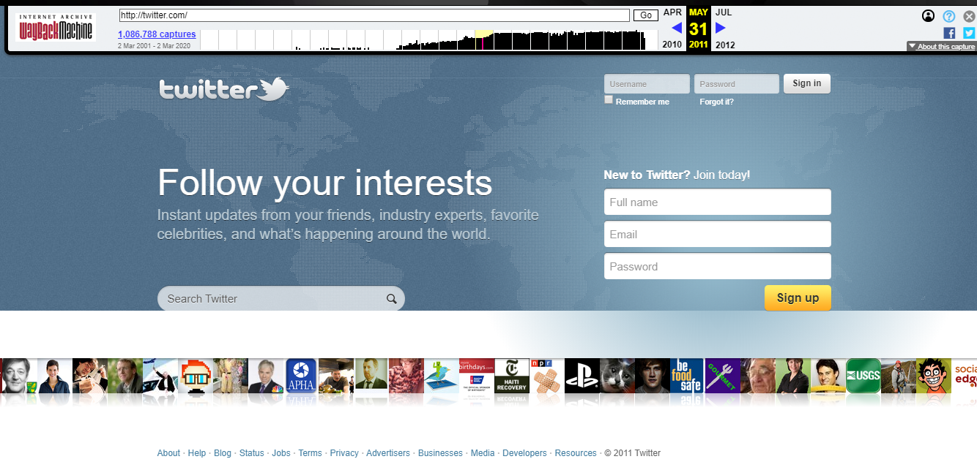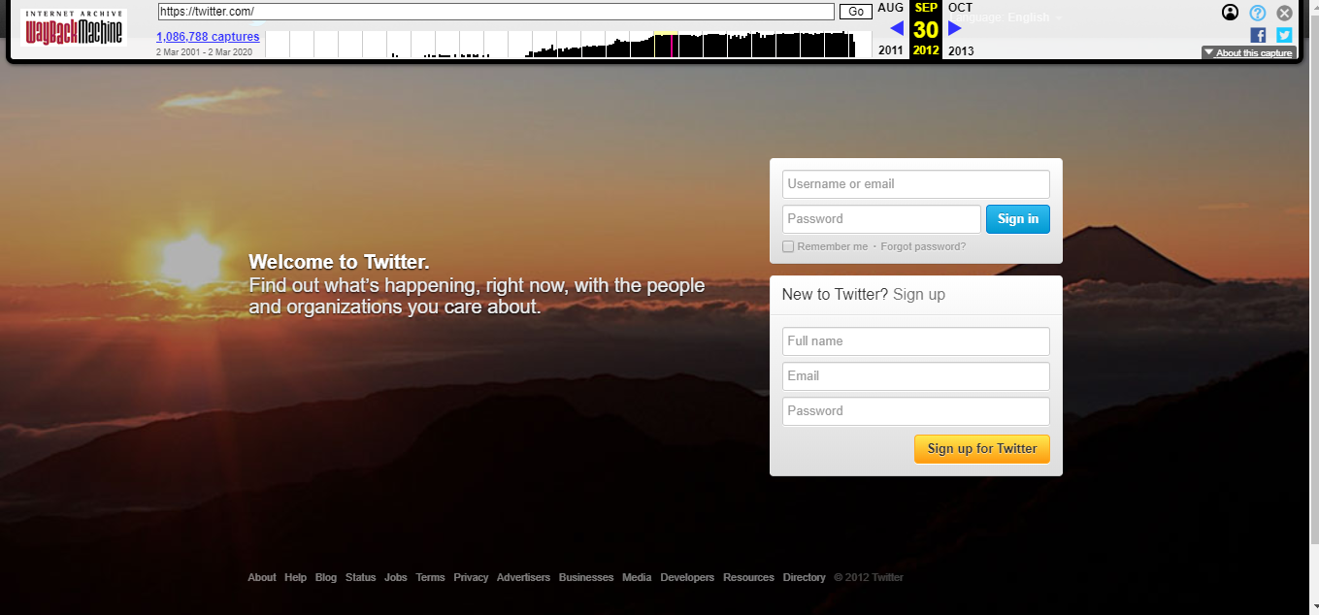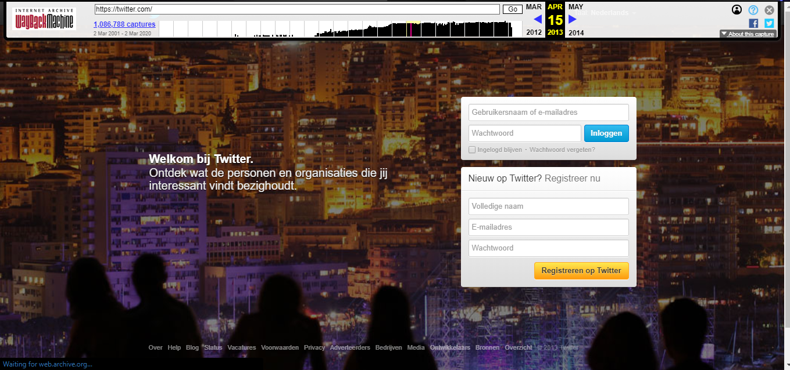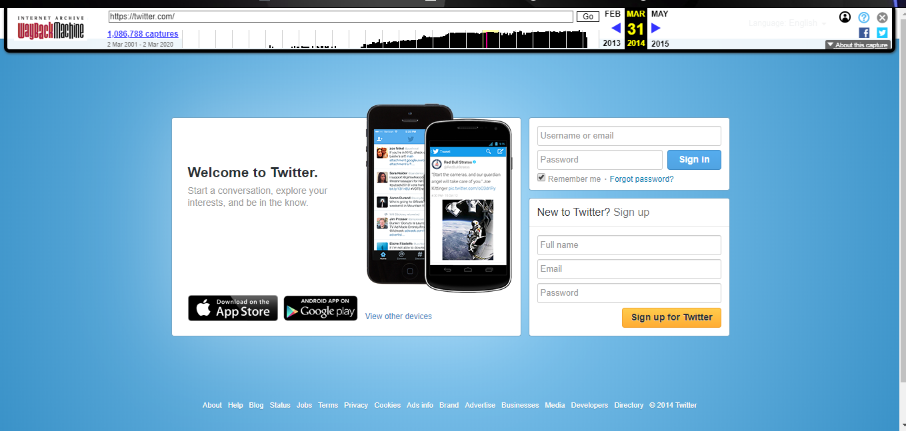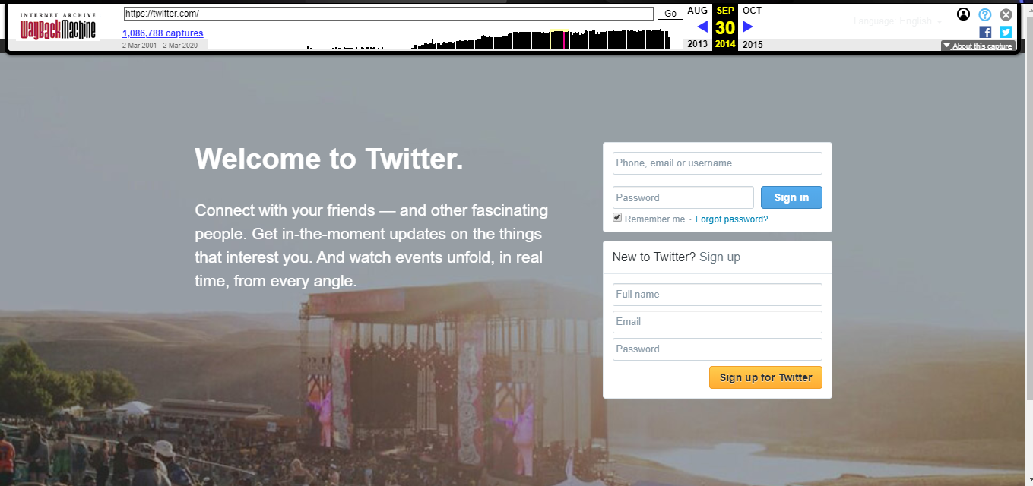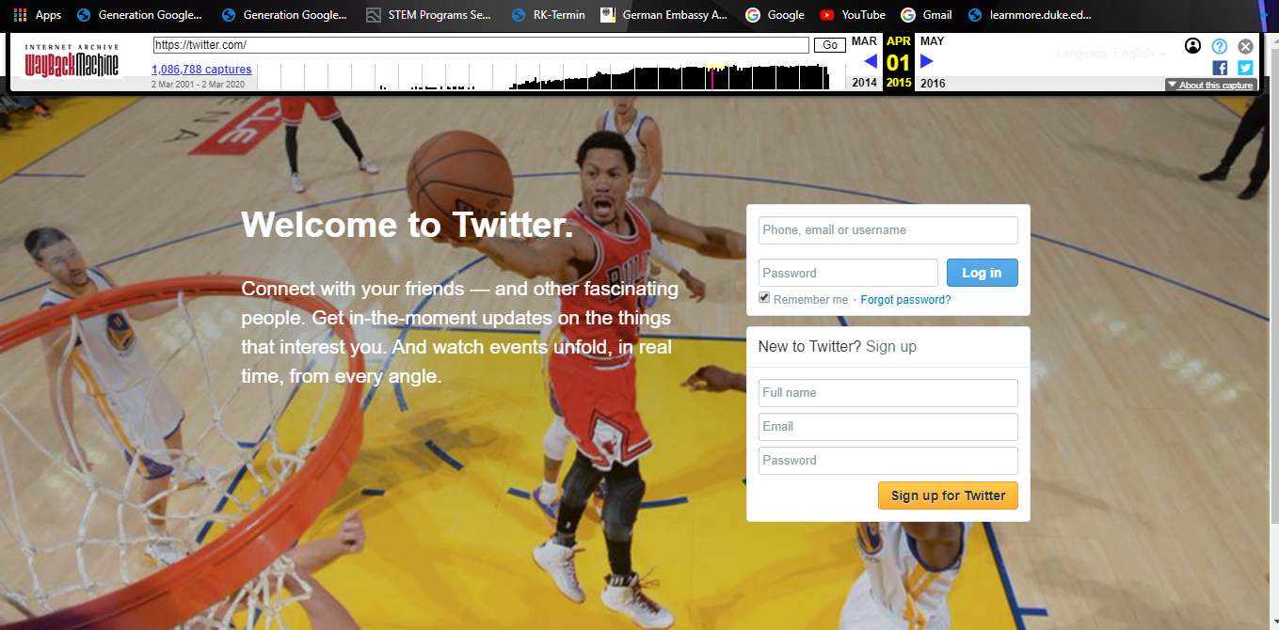**

* **Snapchat**

In entirety, Snapchat has evolved a lot and it's mostly been positives with a few frustrating layout changes. But this just one of the things we’ll have to deal with, especially considering that despite the coming up of several new social media apps, this has stuck, and the likelihood of its popularity diminishing is highly unlikely.

I personally don’t like yellow color but I like the logo I noticed a great change from 2011.

**2019**

**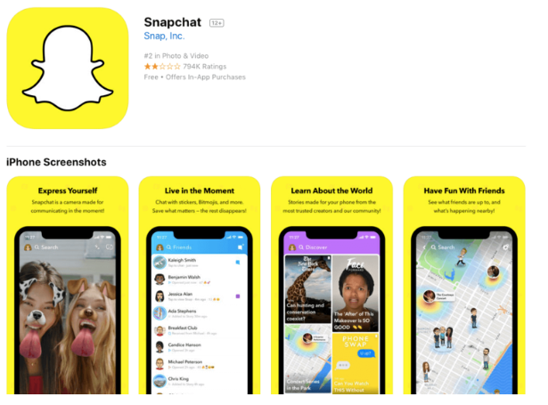**

**2011**

**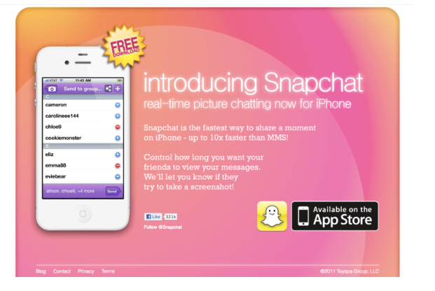**

* **Tik –Tok**

Tik Tok, formerly known as Musical.ly, is an app where people can make videos to audio, and then post it to the public. Musical.ly, launched in April of 2014, was most commonly used by people to dance to music, lip sync, and then share with others. All users and content on the app were transferred as the app merged with Tik Tok.

Musical.ly had rapidly grown, but Tik Tok had gained even more attention. Taking note of the new international influence, the app was ranked as the second most downloaded worldwide by November of 2018.

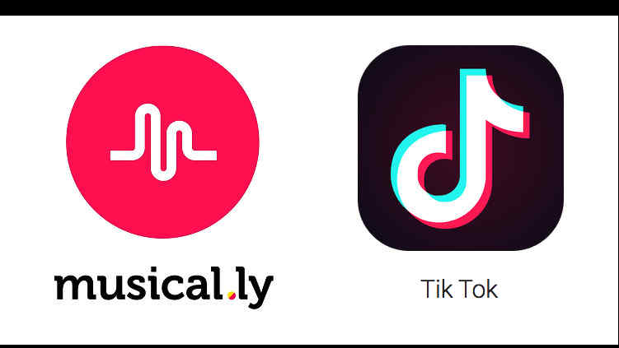

**3**. There are 12 types of Websites:

**Portal:** Addis Ababa university portal(http://www.aau.edu.et/), UAB Medicine(https://www.uabmedicine.org/), eService: Ethiopian Government Electronic Services(https://www.eservices.gov.et), iGoogle(https://igoogleportal.com/),AOL(https://www.aol.com)

* Addis Ababa university portal is designed to provide services for Students, Applicants, Academic Staff and for those who play management role at Addis Ababa University.
* UAB's top-ranked medical professionals found a platform through which they can reach many visitors and actual patients with health concerns.
* The Ethiopian Government Electronic Services portal provide electronic public services to citizens, non-citizens, businesses, governmental & NGO.
* iGoogle Portal is your personalized home page. Add news, weather, games and stuff from across the web to your page.
* The mission of the Academies of Loudoun is to empower students to make meaningful contributions to the world in the fields of science, technology, engineering

**News:** NBCNews(https://www.nbcnews.com/), EBC(https:// EBC.com), BBC(https://www.bbc.co.uk/news), CNN(https://www.cnn.com/), Al Jazeera(https://www.aljazeera.com/)

* NBCNews is a website that shows Breaking News, Latest News and Current News in the world. NBC News is the news division of the American broadcast television network NBC.
* Ethiopian Broadcasting Corporation EBC is a 24 hour working public media. ... Amharic News.
* BBC News provides trusted World and UK news as well as local and regional perspectives. ... The latest global news, sport, weather and documentaries
* CNN Digital is the world leader in online news and information and seeks to inform, engage and empower the world.
* Al Jazeera Media Network is a major global news organization, with 80 bureaus around the world.

**Informational :** https:// www.Wikipedia.org , https://www.CNET.com, https://www.Facebook.com, https://www.Youtube.com, https:// www.WHO.com

* Wikipedia.org is a well known free internet encyclopedia. It has been a trusted source of information on various subjects.
* CNET.com provides tech news; product review, and prices, offer software downloads.
* Facebook has become first source of different information like, local news, and local debates.
* Youtube is also a most informative websites.
* Website of WHO (World Health Organization) is one of the top 10 most informative websites.

**Business/ Marketing :** Amazon(https://www.amazon.com/),2merkat( https://www.2merkato.com), manychat(https://www. 2merkat.com), hubspot(https://www.hubspot.com/), gemius(https://www.gemius.com/homepage.html)

* Amazon Web Services offers reliable, scalable, and inexpensive cloud computing services. Free to join, pay only for what you use.
* 2merkato provides business information for investors, suppliers, buyers, traders who are engaged or want to engage in business activities in Ethiopia.
* hubspot offers a full platform of marketing, sales, customer service, and crm software — plus the methodology, resources, and support — to help businesses grow better. get started with free tools, and upgrade as you grow.
* gemius is a business consulting company, providing data, solutions and recommendations in the area of online advertising campaigns’ management as well as websites’ monitoring and analysis as far as users’ profiles are concerned.
* manychat.com is automate & combine facebook messenger, sms, and e-mail to grow your business. build campaigns intuitively with our visual editor.

**Educational:** https://www.The Futures Channel.com, https://www edX.com, https://www Codecademy.com, https://www W3Schools.com, https://www .Brightstorm.com

* The Futures Channel provides students and educators with an excellent resource collection of inspirational Educational videos about current trends and advancements in Science, Engineering, and Technology.
* edX is a massive open online course (MOOC) provider. It hosts online university-level courses in a wide range of disciplines to a worldwide student body, including some courses at no charge.
* Codecademy is an online interactive platform that offers free coding classes in 12 different programming languages including Python, Java, JavaScript (jQuery, AngularJS, React.js), Ruby, SQL, C++, Swift, and Sass, as well as markup languages HTML and CSS.[
* W3Schools is an educational website for learning web technologies online. Content includes tutorials and references relating to HTML, CSS, JavaScript, JSON, PHP, Python, AngularJS, React.js, SQL, Bootstrap, Sass, Node.js, jQuery, XQuery, AJAX, XML, Raspberry Pi, C++, C# and Java.
* Brightstorm is an online learning platform for teenagers.

**Entertainment**: https://www. youtube.com , https://www. netflix.com, https://www. imdb.com, https://www. spotify.com, https://www. soundcloud.com

* spotify is a digital music service that gives you access to millions of song
* soundcloud is a music and podcast streaming platform that lets you listen to millions of songs from around the world, or upload your own.
* netflix is site that show movies & tv shows online or stream
* imdb is the world's most popular and authoritative source for movie, tv and celebrity content.
* Youtube is the world's most popular and authoritative source for movie, tv and celebrity content

**Advocacy:** http://www.worldadvocacy.com , http://www.greenpeace.org , http://www.sierraclub.org , http://www.environmentaldefense.org , http://ash.org/

* Worldadvocacy.com is the world's premier list of advocacy groups.
* Greenpeace is a non-governmental environmental organization
* The Sierra Club is the most enduring and influential grassroots environmental organization in the United States.
* Environmental Defense Fund Guided by science and economics, that tackle urgent threats with practical solutions.
* Ash.org Since 1967, theye’ve been defying the odds and pushing back against Big Tobacco, leading to a reduced death toll from tobacco  
  http://www.worldadvocacy.com/images/10v.gif

**Blog:** https://www. wordpress-com/, https://www.wix.com/, https://www. Squarespace.com, https://www. Blogger.com, https://www. Medium.com

* Wordpress is a popular freemium blog hosting site
* Wix offers blog builder solution with an easy start for bloggers.
* Squarespace is a convenient all-in-one web builder, hosting provider and platform for bloggers.
* popular free blogging sites, Blogger site is re https://www latively easy to use.
* Mediunm is a new medium that has its backbone in the blogging world.

**Wiki:** https://www. AboutUs.com, https://www.Astrodatabank.com, https://www. Baidu\_Baike.com, https://www.Baike.com, https://www. Ballotpedia.com

* AboutUs.com is a wiki Internet domain directory. It listed websites along with information about their content.
* Astrodatabank is a wiki website containing a collection of astrological data.
* is a Chinese-language, collaborative, web-based encyclopedia owned and produced by the Chinese search engine Baidu.
* It is China's second largest wiki site behind Baidu Baike
* Ballotpedia is a nonprofit and nonpartisan online political encyclopedia written by a staff of researchers and writers.

**Social Network:** https://www.Academia.edu, https://www.About.me., https://www.AsianAvenue.com, https://www.ASmallWorld.com, https://www CaringBridge.com

* Academia is Social networking site for academics/researchers
* About.me is Social networking site
* AsianAvenue is a social network for the Asian American community
* aSmallWorld is European jet set and social elite worldwide
* CaringBridge is Not for profit providing free websites that connect family and friends during a serious health event, care and recovery.

**Content Aggregator**

* Alltop(https://alltop.com/,) is one of the biggest names in content aggregation and deservedly sits in first place on this list.
* Popurls(**:** http://popurls.com) pulls in content from a variety of social networks, blogs, and news organizations.
* The Web Lis(/, http://theweblist.net/,)t functions similarly to Popurls in that it’s a one-page content aggregator website that collects content from a huge variety of sources.
* WP News Desk(http://wpnewsdesk.com/,) is a content aggregator website that focuses specifically on WordPress.
* Blog Engage(http://www.blogengage.com/) is one of the most popular blog content aggregators out there.

**Personal**:

### [Nia Shanks](https://www.niashanks.com/)(https://www.niashanks.com/)

### [Simon Sinek](https://startwithwhy.com/)(https://startwithwhy.com/)

### [Ellen Skye Riley](http://ellensriley.com/)(http://ellensriley.com/)

### Tim Harford(http://timharford.com),

### [Joshua McCartney](https://www.joshuamccartney.com/)(https://www.joshuamccartney.com/)

**4.**  There are **six Criteria’s** for Websites these six criteria deal with the content of Web sites rather than the graphics or site design.

**1. AUTHORIT**

Authority reveals that the person, institution or agency responsible for a site has the qualifications and knowledge to do so. Evaluating a web site for authority:

• Authorship: It should be clear who developed the site.

• Contact information should be clearly provided: e-mail address, snail mail address, phone number, and fax number.

• Credentials: the author should state qualifications, credentials, or personal background that gives them authority to present information.

• Check to see if the site supported by an organization or a commercial body

1. **PURPOSE**

The purpose of the information presented in the site should be clear. Some sites are meant to inform, persuade, state an opinion, entertain, or parody something or someone. Evaluating a web site for purpose:

• Does the content support the purpose of the site?

• Is the information geared to a specific audience (students, scholars, general reader)?

• Is the site organized and focused?

• Are the outside links appropriate for the site?

• Does the site evaluate the links?

• Check the domain of the site. The URL may indicate its purpose.

1. **COVERAGE**

It is difficult to assess the extent of coverage since depth in a site, through the use of links, can be infinite. One author may claim comprehensive coverage of a topic while another may cover just one aspect of a topic. Evaluating a web site for coverage:

• Does the site claim to be selective or comprehensive?

• Are the topics explored in depth?

• Compare the value of the site’s information compared to other similar sites.

• Do the links go to outside sites rather than its own?

• Does the site provide information with no relevant outside links?

1. **CURRENCY**

Currency of the site refers to:

1, how current the information presented is, and

2, how often the site is updated or maintained. It is important to know when a site was created, when it was last updated, and if all of the links are current. Evaluating a web site for currency involves finding the date information was:

• First written

• Placed on the web

• Last revised Then ask if:

• Links are up-to-date

• Links provided should be reliable. Dead links or references to sites that have moved are not useful.

• Information provided so trend related that its usefulness is limited to a certain time period?

• The site has been under construction for some time?

1. **OBJECTIVITY**

Objectivity of the site should be clear. Beware of sites that contain bias or do not admit its bias freely. Objective sites present information with a minimum of bias. Evaluating a web site for objectivity:

• Is the information presented with a particular bias?

• Does the information try to sway the audience?

• Does site advertising conflict with the content?

• Is the site trying to explain, inform, persuade, or sell something?

1. **ACCURACY**

There are few standards to verify the accuracy of information on the web. It is the responsibility of the reader to assess the information presented. Evaluating a web site for accuracy:

• Reliability: Is the author affiliated with a known, respectable institution?

• References: do statistics and other factual information receive proper references as to their origin?

• Does the reading you have already done on the subject make the information seem accurate?

• Is the information comparable to other sites on the same topic?

• Does the text follow basic rules of grammar, spelling and composition?

• Is a bibliography or reference list included?

**Instagram, Facebook, Telegram**

* **Instagarm,** as listed in the above criteria. Instagram fulfills the criteria’s listed above. For example: The developer ,contact is known, Credentials is also clearly stated, the aim of the website
* **Kevin Systrom** and **Mike Krieger** in 2012. They founded Instagram in a San Franscisco co-working space in 2010.
* **Instagram** is a photo sharing app which allows users to assign filters to photos and share them with followers
* **Facebook** fulfills the criteria listed above .For example: The developer ,contact is known, Credentials is also clearly stated, the aim of the website
* **Facebook** is an American online social media and social networking service based in Menlo Park, California and a flagship service of the namesake company Facebook, Inc. It was founded by Mark Zuckerberg, along with fellow Harvard College students and roommates Eduardo Saverin, Andrew McCollum, Dustin Moskovitz and Chris Hughes.
* **Telegram**, as listed in the above criteria. Instagram fulfills the criteria’s listed above. For example: The developer ,contact is known, Credentials is also clearly stated, the aim of the website
* Telegram was started in 2013 by the brothers Nikolai and **Pavel Durov**, the creators of VK, the largest social network of Russia.
* **Telegram** is a cloud-based instant messaging and voice over IP service. Telegram client apps are available for Android, iOS, Windows Phone, Windows NT, macOS and Linux.

Telegram, facebook, instagram as they are popular websies they have an author ,objective ,coverage, purpose…and all the criteria’s .

### Reference

### Internet

### ITSE-2192 Fundamental of web Design and Development lecture one

### https://web.archive.org/